Phylogenetic Collection Assignment
Objectives
- Connect the diversity of phyla we discussed in class with the real world.
- Identify and connect particular phyla of organisms with their characteristic habitats.
- Compare and contrast organisms within the different phyla using phylogenetic trees.

Assignment
- You will begin by “collecting” organisms from 10 different phyla.
  - To “collect” an organism, you will provide a photograph of the whole organism or part of it
    - e.g. photograph a hawk or a feather from a hawk that you find
  - You may get samples from anywhere – local park, streams and lakes, your yard, campus, etc.
- Photographs must be taken by you, or you had to have been present when the photo was taken – for example if your friend took the photo of a fish you caught, that is fine, and awesome!
- Pictures can be from the past, for example, if you took a trip to Hawaii last year and have a photo of a dolphin you swam with, that is fine. Again, you have to have been there – and preferably past pictures will be from very recently! Not from a trip when you were 5. Part of the goal is to get you out looking for species of different phyla! No more than 3 of your taxa should be from past (pre-BIO211) pictures.
- You will determine the taxonomy of each species, including the Domain, kingdom, phylum, class, order, family, genus, and species.
  - To figure out the taxonomy of an organism – particularly what phylum it is in use the Encyclopedia of Life (EOL) website at http://eol.org/ or Wikipedia
- An important note about Wikipedia - it is often incorrect, or follows a taxonomy different from the one we are using in class. For example, we will consider all flowering plants (angiosperms) to be in the phylum anthophyta! Wikipedia will use magnoliaphyta, tracheophyta and others. So, if you have a plant that produces flowers, whether a tulip, green pepper, or maple tree, it is the same phylum - Anthophyta. The biggest mistake folks make is have multiple organisms from the Anthophyta. So if you want to have multiple plants, make you could have an angiosperm, a gymnosperm, a bryophyte and a pteridophyte!
  - Note that for plants, many sources will use the term “Division” instead of “Phylum”!!
- You will specify where each of your samples came from in terms of geography (e.g. Moore Park) and habitat (e.g. Pine forest) both with a photograph of where the specimen was collected and a description
- Create two phylogenetic trees based on n the hierarchical taxonomic classification of each organism (e.g. Domain, kingdom, phylum, class, order, family, genus, species).
  - One tree will show all 10 phyla you collected.
  - For the second tree choose 5 of your 10 organisms and combine them with the 5 organisms that I choose for you (see below).

Assignment presentation and content
You will present your collection of organisms from 10 phyla and the 2 phylogenetic trees that you construct in a series of PowerPoint (PPT) slides.
Your final assignment should include 12 slides, 1 for each of the 10 organisms you collect and 1 for each of your phylogenetic trees.
A. Each of your 10 organism PPT slides should contain:
- The photo of the specimen – either the entire organism or a piece of it, e.g. a bird or a feather, a deer or some hair, a Ponderosa Pine or just a cone.
- The organism’s common name if available e.g. American Robin
- The organism’s Taxonomy in appropriate hierarchical order – e.g. Domain, kingdom, phylum, class, order, family, genus, species
- The geographical location you collected it and a photograph of that location
- A description of the habitat in which that organism occurs – make sure to be fairly detailed. For example, don’t just say “forest” – be clear on what types of forest.
- Does the actual sample you collected represent or contain:

  - The Sporophyte generation
  - The Gametophyte generation
  - Gametes
  - An Adult
  - A Spore
  - A Seed
  - Diploid cells
  - Haploid cells

- Does the organisms include the following anywhere in their life cycle (not just in the part that you collected)

  - The Sporophyte generation
  - The Gametophyte generation
  - Gametes
  - An Adult
  - A Spore
  - A Seed
  - Diploid cells
  - Haploid cells

- List at least one specialized adaptation that is relatively unique to that organism, for example feathers for flight

B. Phylogenetic Tree slides
You will create 2 phylogenetic tree slides. Follow the method below to create your trees.
In the second lab we worked on creating phylogenetic trees based on derived characters compared to a selected outgroup. For this activity, instead of relying on characters, you will draw a partial phylogenetic tree to show the relationships between your selected organisms, based on taxonomy, i.e. their kingdom, phylum, class, order, family, genus, and species.
For example, given organisms 1 – 5 with the following taxonomic classifications:
Organism | Kingdom | Phylum | Genus | Species
1 | A | F | K | U
2 | A | F | K | V
3 | A | F | M | X
4 | A | G | N | Y
5 | B | H | O | Z
- The difference between 1 and 5 is at the kingdom level- they are extremely different
- The difference between 3 and 4 is at the phylum level- they are in the same kingdom but still very different
- 1 and 2 differ only at the species level- they are different, but closely related.
- Note that this table only shows Kingdom, Phylum, Genus and Species. Your trees should include Class, Order, and Family as well.
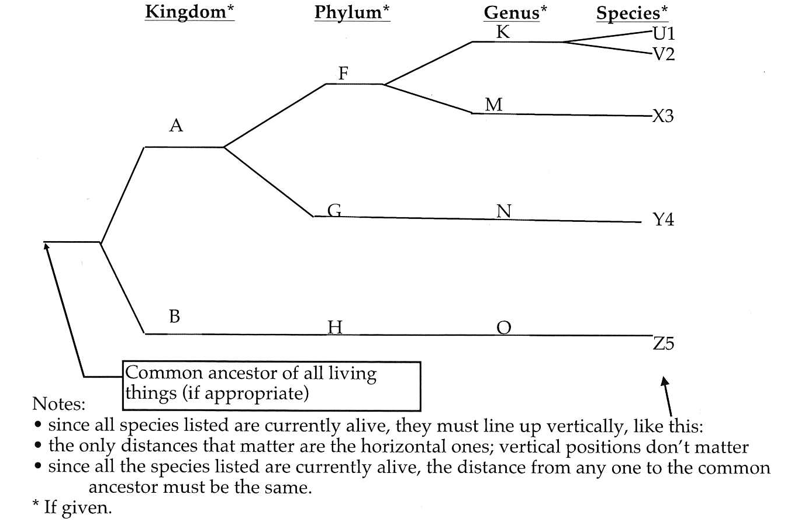
Each phylogenetic tree slide should contain your table, like the one above, which will include kingdom, phylum, class, order, family, genus, and species of each organism and the phylogenetic tree you construct. (Use the line drawing tool and text boxes to construct and label the tree)
Tree #1
- Create a phylogenetic tree by completing a table and a tree for your 10 organisms
Tree # 2
- Create a phylogenetic tree of 5 organisms chosen from your initial group of 10 and combine them with the 5 organisms already listed in the table below.
Org | Domain | Kingdom | Phylum | Class | Order | Family | Genus | Species
1
2
3
4
5
6 | Bacteria | Bacteria | Proteo - bacteria | Gamma Proteo - bacteria | Pseudo monadales | Pseudomonadaceae | Pseudo - monas | aeruginosa
7 | Eukaryota | Protista | Euglenozoa | Euglenida | Euglenales | Euglenaceae | Euglena | gracilis
8 | Eukaryota | Plantae | Gingkophyta | Gingoopsida | Gingkoales | Ginkgoaceae | Ginkgo | biloba
9 | Eukaryota | Animalia | Cnidaria | Anthozoa | Actiniaria | Actiniidae | Epiactis | prolifera
10 | Eukaryota | Fungi | Basidiomycota | Agaricomycetes | Agaricales | Amanitaceae | Amanita | jacksonii

When you are done – submit the final project as a pdf. In PPT go to File > Save as > pdf.
MAKE SURE YOU HAVE COMPLETED ALL SECTIONS OF THE ASSIGNMENT. MOST COMMON LOSSES OF POINTS IS NOT COMPLETING ALL SECTIONS!
This project is due by Sunday, August 5 Midnight!

